# In-class Assignment 1

Your company will deploy a new Application to Azure services. The application is a 3-tier application with the following elements: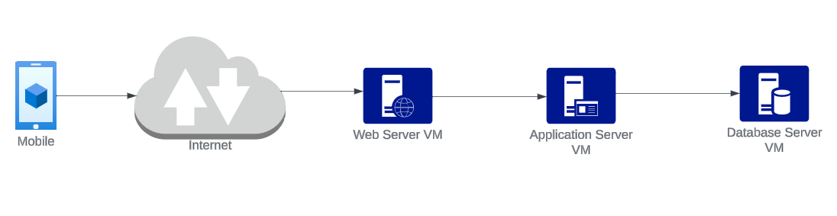

Requirements:

* The Webserver and the Application Server VM components must scale out. Design your architecture to account for it.
* You have to design the security of this application respecting a number of criteria:
  + Only the web server is visible to the Internet, via HTTPS connections.
  + The Application Server can only accept access from the Web Server. The Application server listens on port 6050.
  + The Database Server must be protected. Only the Application Server VMs can access it, and it listens on the port 3306.
* Your network design should isolate the traffic directly accessed from the Internet (to reach the Web Server) from the internal servers.
* You must provide a bastion host access to manage the servers.
* You must define the identities of the support personnel:
  + John Doe, Platform Engineer, must be able to access the web server and the application server.
  + Mary Jane, DevOps engineer, must access all the 3 tiers.
  + Rod Smith, Developer, must access the three tiers.
  + Samantha Burns, Developer, must access the three tiers.

Deliverables:

1. Production Environment. An architecture proposal covering the security of the production environment, including:

* Network and boundary protection (firewalls0
* Host firewalls
* User, Group, and Role design.
* IAAS resources protection
* Endpoints

2. Development and Quality environment. An architecture proposal for the development environment, specifying the same components listed above in the production environment.

3. Business Continuity. You must also design a business continuity strategy. What is the backup mechanism? What data must be backed up at what frequency? Where do backups are stored?

All **decisions taken must be explained and supported by arguments**. For example, if you decide to deploy a bastion host in a VM, offer the specific arguments for the decisions.

You must submit a report (max 6 pages) with the architecture and its decisions and supporting arguments. You must also design the identity and access control design (users, groups, roles, access).